3.2: Data Storage & Structure

Answers 3.2

* **Step 2. Extract the ERD**

* **Step 3. Create the first draft of a data dictionary**
* Take a moment to examine your ERD. Does the Rockbuster database have a snowflake schema or a star schema? Write a brief explanation for your answer
* The Rockbuster database uses a **snowflake schema** because: It normalizes data into multiple related dimension tables, fact tables like rental and payment reference these normalized dimension tables through foreign keys.
* List all the fact tables and all the dimension tables in the schema. For each table, list every column and its data type, and write a brief description of the column. To get an idea of what this should look like, check out these example fact and dimension tables.

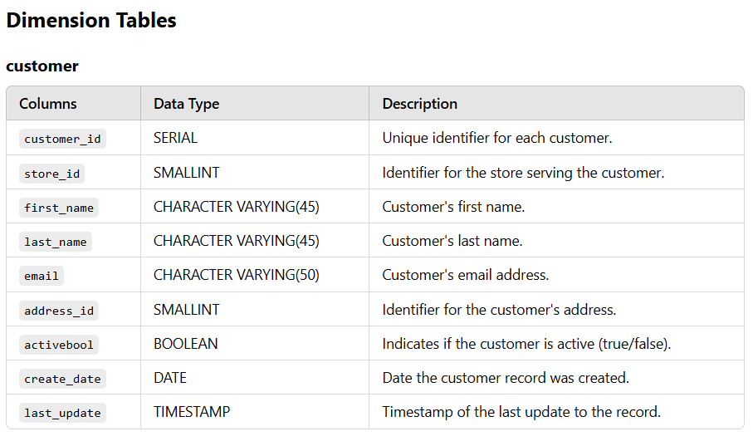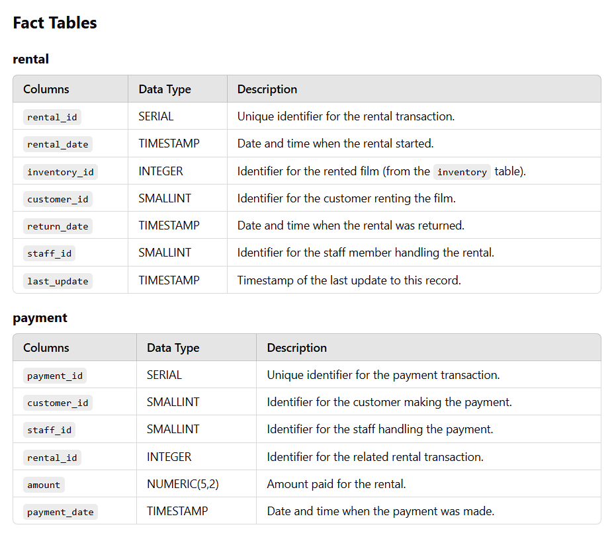

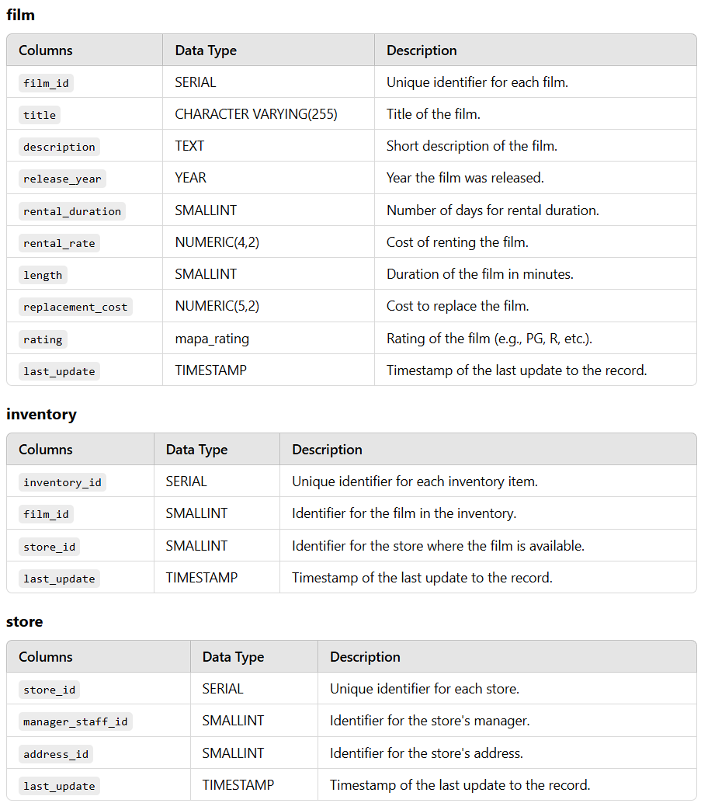

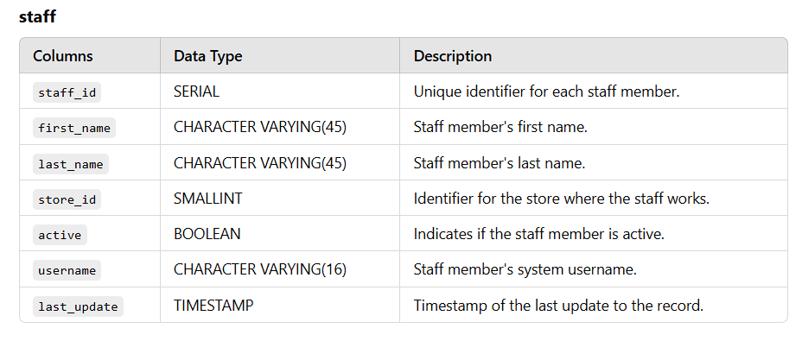

* **Step 4. Find information:**
* Which actors brought Rockbuster the most revenue?

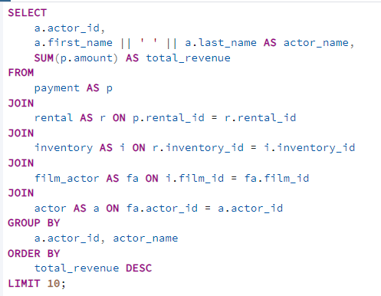

* What language are the majority of movies in the collection?

